# Strategy

To determine how to position the website to best meet the business requirements of the client, a number of activities were undertaken. This included understanding the business objectives in some depth through competitor benchmarking; a user needs analysis with personas and scenarios developed and the development of a concept map or model.

## Business Objectives

### Competitive Benchmarking

As part of the development process for designing the CDU’s 2017 Code Fair site, we performed competitive analyses of 2 similar websites.

Competitor 1 - https://www.cyberchallenge.com.au

Competitor 2 - http://www.eng.unimelb.edu.au/engage/schools/codemasters

Our criteria for choosing these websites was based on the following themes:

- Code Fair

- Code Masters

- Coding Competition

- University Coding

We focused on information inventory, functionality inventory, visual layout and general user experience. Main observations focused on User Experience, Usability, Responsive Design and Accessibility.

Strengths

* Responsive Design
* Unobtrusive JavaScript
* Encryption / privacy
* Availability of content from past events
* Page load time
* Valid / semantically correct coding
* Accessibility
* Information well-laid out, easily findable, hard to get lost

Weaknesses

* Navigation – missing back / top buttons, lacking hovering navigation
* JavaScript links broken when disabled
* Fails contrast test
* Incorrect form usage
* Content incorrectly labeled, or not obvious to user

Although we discovered that the sites were overall valid and accessible and were responsive, it really was the little things, that made the sites not as “user friendly” as they could have been, for example just missing a “Back to top” button on long pages.

## User Needs {personas}

The main user groups most likely to use the website are college or high school students and representatives form the IT industry (Appendix 2). This isn’t only the target audience but who we believe will have a need and a want to visit the website.

What we want to achieve for the website is not only to get students to sign up, which is a main focus of the site, we also want it to be as accessible to other users. Having said that, we also want to make sure we incorporate the little things and make it easier to get around the site.

We learnt a few things from working with our wireframe and running our first simple usability test with the wireframe. Most of these changes were to do with the placement of content and adjusting the number of navigation links per page.

With the full user testing (Appendix 4) we have learnt a lot more and focusing on accessing the required information the user requires in as little effort as possible, this includes both the IT representative and the students.

### Concept Map

Using the idea that we want to promote this year’s event as well as get industry involved (and not forgetting a repository of old events), we designed the concept map below.

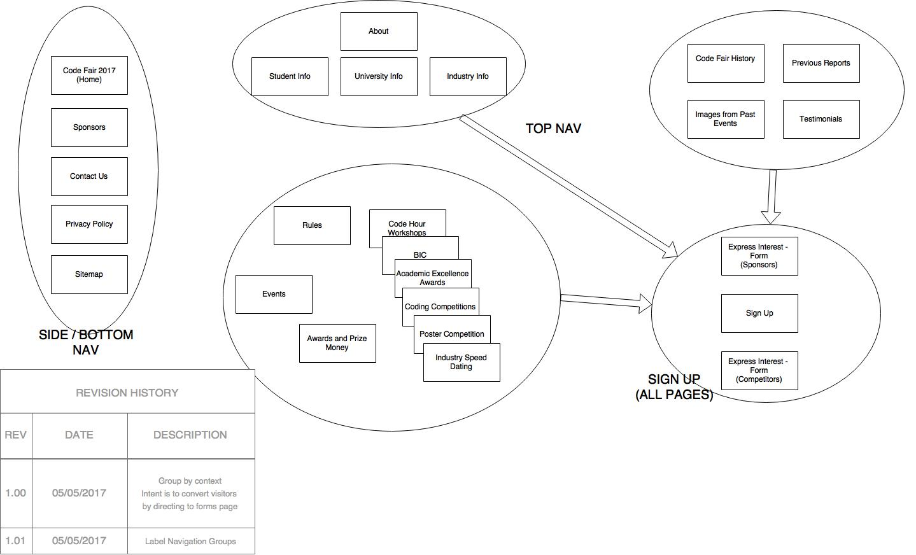

The main concept was to get students involved and IT involved, so our main focus was having signup link form all pages and have it visible. Second to this we wanted access to “more information” and last years events, this is also how all the content fell into each group easily. The above map changed slightly towards the end after user testing but the main idea is still the same.